Software Engineering

Lab Activity: Introduction to Netbeans for Java Applications

1. Activity Brief

This activity will introduce the set up of the first Java application in Netbeans Integrated Development Environment (IDE), including Git and automated unit testing.

1.1 First Java Application

A complete guide is available at: https://netbeans.org/kb/docs/java/quickstart.html

To set up a Java standalone project
Open Netbeans, go to File and New Project… to create a new java project.

Click Next.

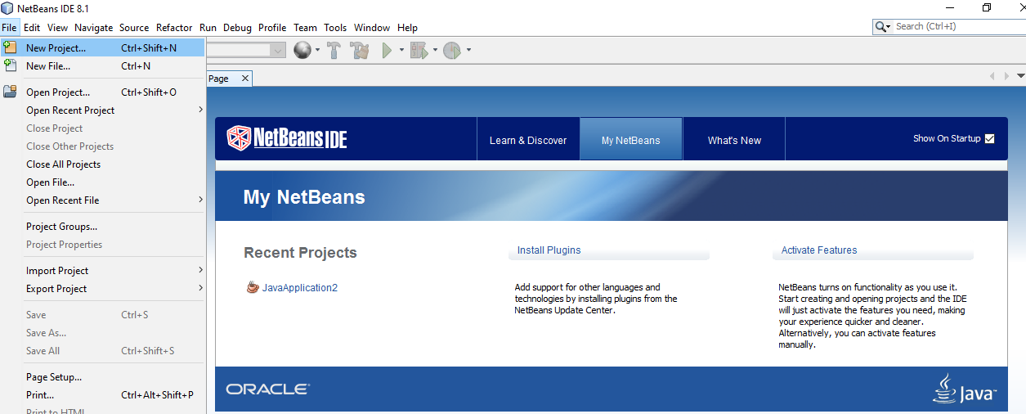

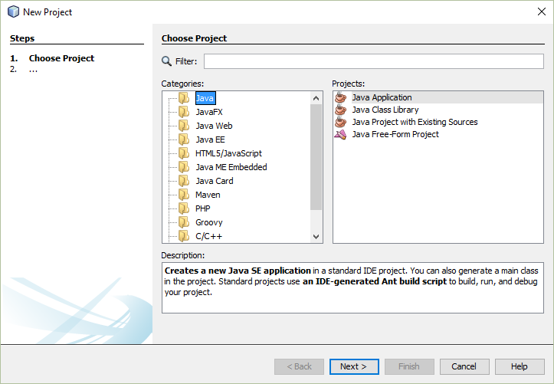

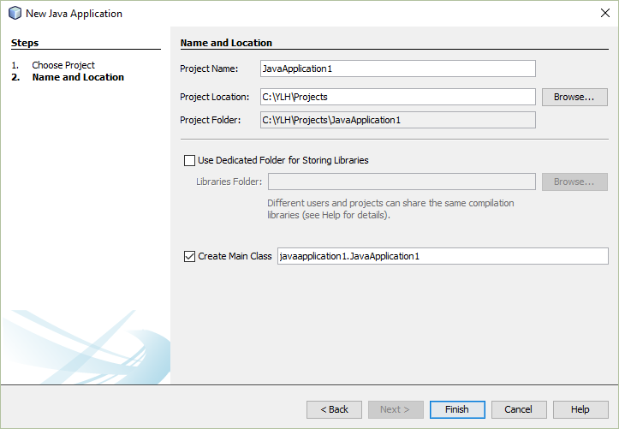
In your Home drive (H: at the University network), create a Java application, named JavaApplication1.

Click Finish.

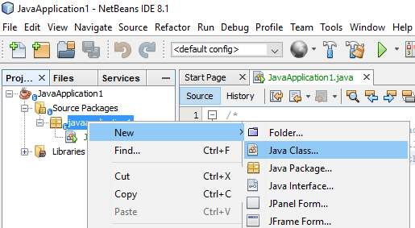

Right click on JavaApplication1 to create a new java file, named Person.

Click Finish.

You could then either enter the code in the file, or copy and paste the code you have into the file.
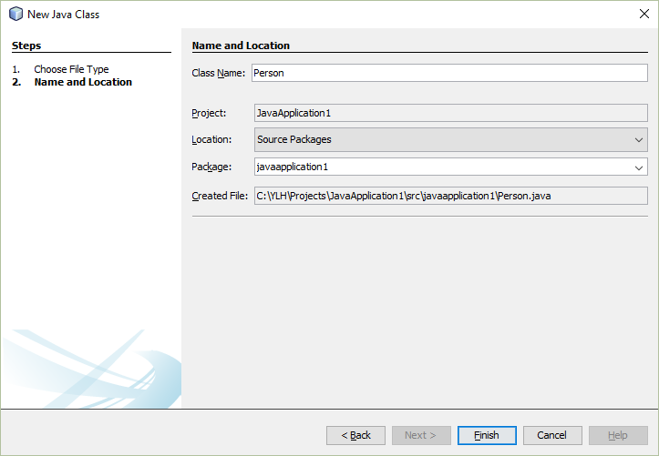
Right click on JavaApplication1 to create a new java file, named Person.

Click Finish.

1.2 Git Version Control

A complete guide can be found at: https://netbeans.org/kb/docs/ide/git.html

1.2.1. Initialization

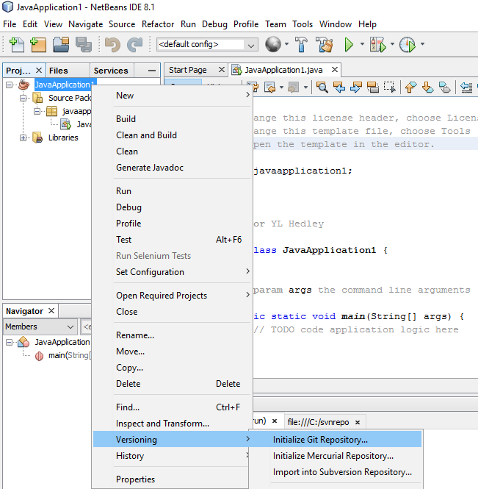
Right click on JavaApplication1, go to Versioning and select Initialize Git Repository…

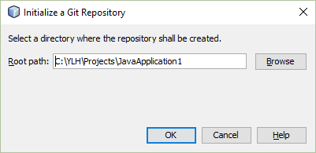
Give the location where the repository will be created (using the default given.)

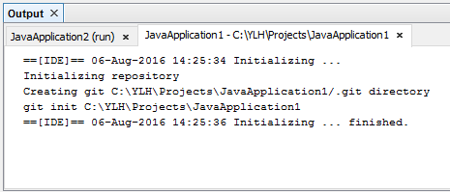
Open Window > Output > Output to view the IDE's report about the progress of the repository creation under your local working directory.

All the project files are marked Added in your Working Tree. To view a file status, place the cursor over the file name in the Projects window. The status of the file in the Working Tree displays in green to the right of the slash like as shown.

After you initialized the Git repository, you either add files or directly commit them to the Git repository.

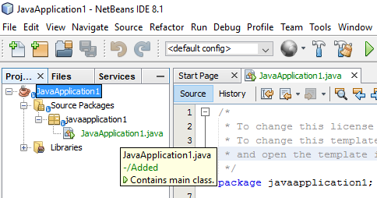

1.2.2. Adding Files to a Git Repository

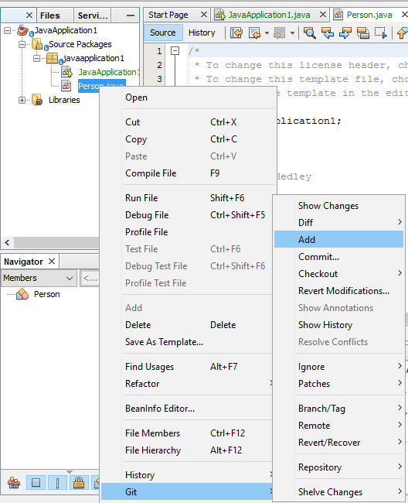
Right click on any file, e.g. Person.java. Go to Git and select Add to add the file to the repository.

1.2.3. Editing Files

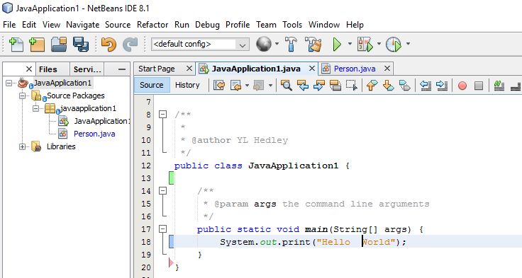

In this example, the JavaApplication1 file has been added to the repository.

To view changes in the Source Editor:
Red indicates lines that have been removed since the earlier revision.

Blue indicates lines that have been changed since the earlier revision.

Green indicates lines that have been added since the earlier revision.

1.2.4. Commit Sources to a Repository

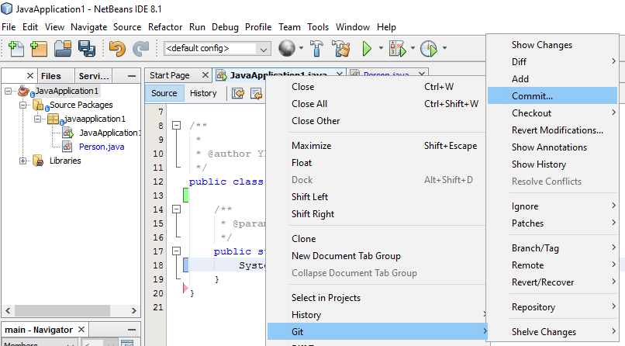
Right click on JavaApplication1. Go to Git and select Commit…

In the dialogue box, give a message.

Select the toggle button, ‘Changes between HEAD and Working Tree’.

To confirm, click on Commit.

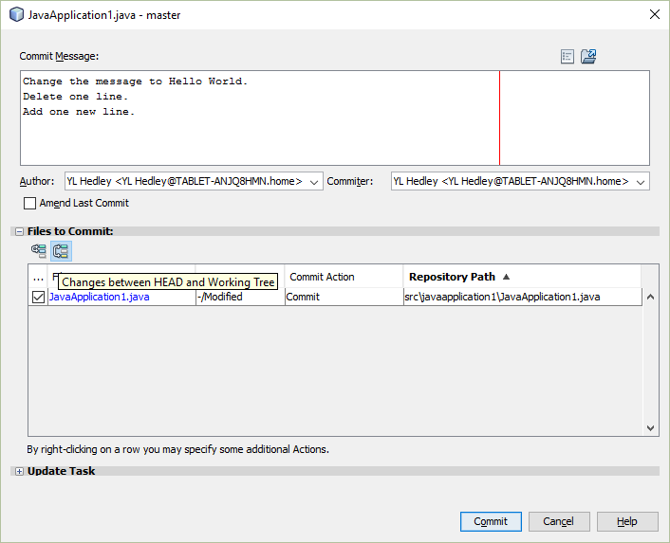

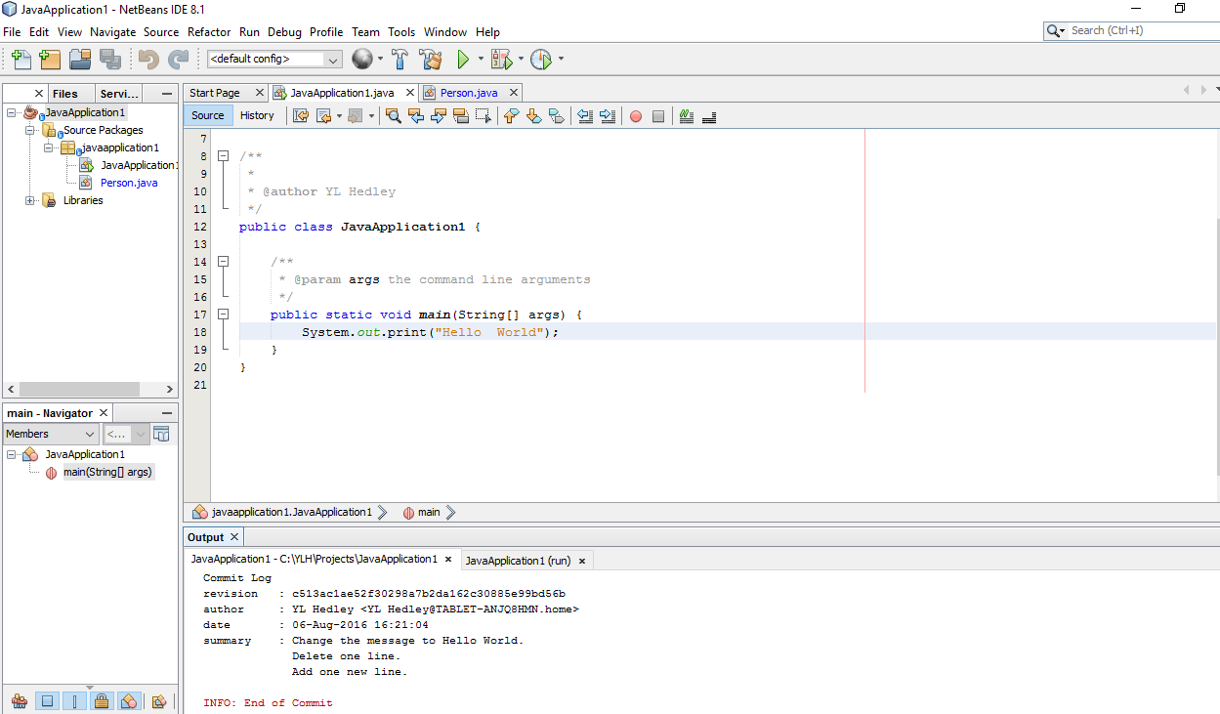
To view the commit, go to Window > Output > Output to view the IDE's report about the progress of the repository creation under your local working directory.

1.3. Junit for Unit Testing

A complete guide can be found at: https://netbeans.org/kb/docs/java/junit-intro.html

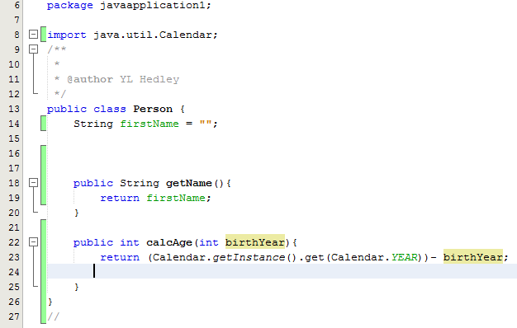
Open the Person.java file and modify the code as above.

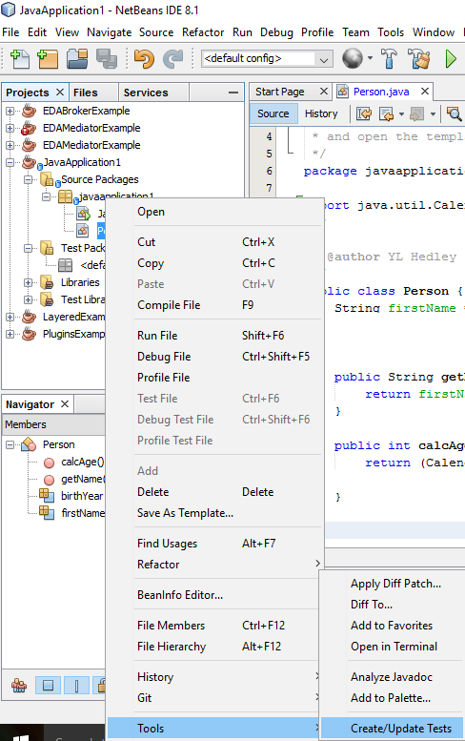
Right click on the Person.java file, select Tools and Create/Update Tests.
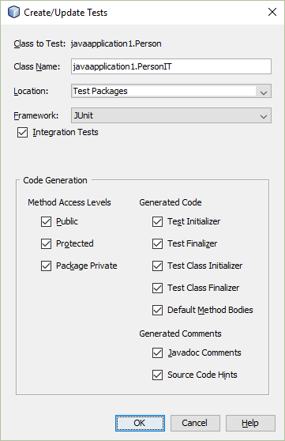
Click OK to continue.
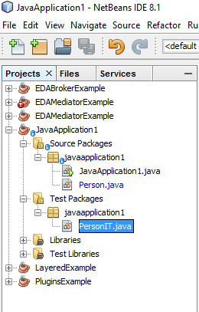
In Test Packages, a test file, PersonIT.java has been created.

Double click on PersonIT.java, and modify the code as below.

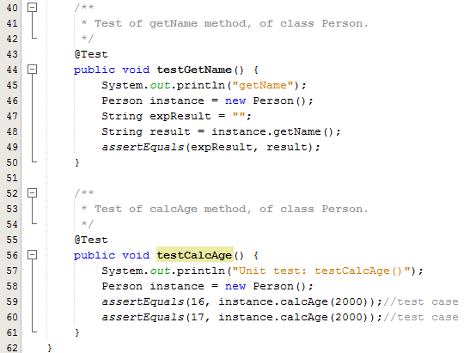

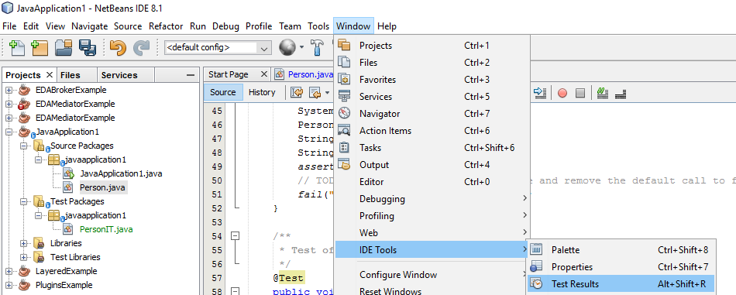

Go to the Window menu and select IDE Tools, Test Results to show Test Results window.

Right click on PersonIT.java and select Run File to run the test file.

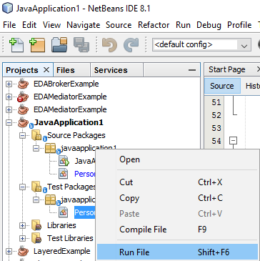

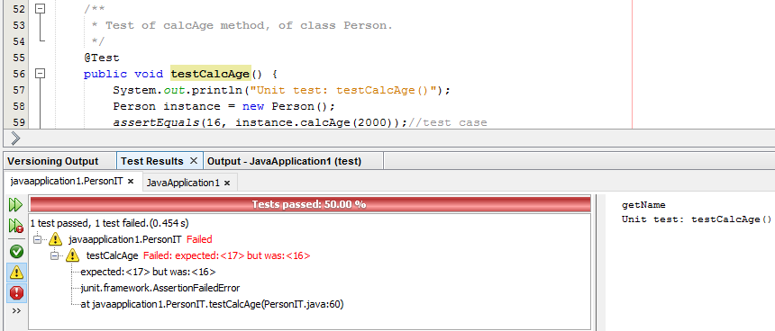

The results of testing are displayed in the Test Results window.

Click on the buttons panel to view the results.

